**LAB 07**

1. Example of feedback & guidance**:**

Without using good UI design principle using principle of good UI design

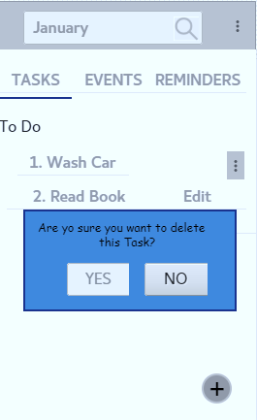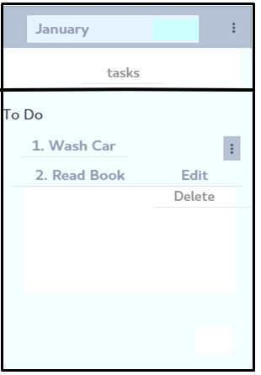

1. How effectively the feedback is provided to the user? Explain with respect to your project.

This alerting facility is provided by the system without delay in time (instantly when person press delete button its shows alert immediately and also instantly replying back without delaying and accepting response on pressing YES, NO button.

2. What kind of help and assistance is provided in your project?

Regarding above given two screen one is using good UI design and another without using good UI design on above given scenario with good UI design having multiple features and user friendly etc. system giving alerting the person that he is sure to delete task or not, it as much user friendly that one without using good UI design

2. Example of feedback & guidance**:**

Without using good UI design principle using principle of good UI design

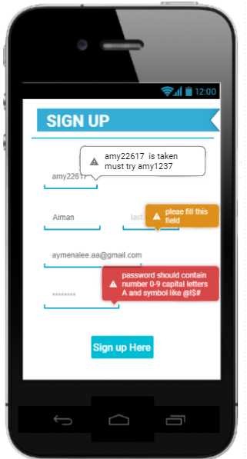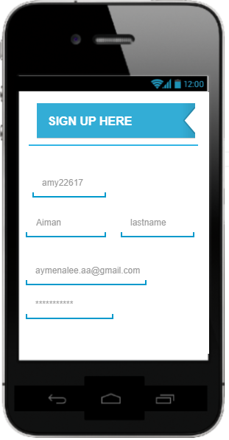

Sign in

1. How effectively the feedback is provided to the user? Explain with respect to your project.

The feedback, guidance, hints & tips and alert facility giving user perfect response instantly without any time delay alerting them responsibly at the moment and also responding back them on user input. Like taking response back that user chooses a new username, or field is empty fill it or not signup person until all fields filled etc.

2. What kind of help and assistance is provided in your project?

One with good UI design providing assistance to the user like giving them feedback not to leave field empty, giving tips in deciding their username and also giving them help in terms of selecting strong password which is system requirement to secure user data and credentials.